**LPM Selection and Comparison SAS Usage Instruction**

**(draft)**

Originally by Ying Shen 2022-6

Revision on 2022-7-22: Update the selection section because there are improved SAS programs and there is no error message any more even though some reasons may not have cases in NNAD. Instead, there are warnings if 0 cases are found for some reasons.

Revision on 2023-12-19: By Ying Shen

* Added the purpose of the SAS programs
* Added RIBD and MRCRS SAS programs

**LPM selection SAS Programs**

**Purpose**: These SAS programs have been designed and implemented to select NETSS messages during the limited production phases from the NNAD PRODUCTION database. NCIRD sends the selected messages to jurisdictions and requests these jurisdictions to resend them in HL7 format to the STAGING database.

There are 3 SAS programs for MPV: Mumps, Pertussis and Varicella. The SAS programs are saved here.

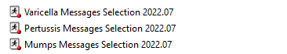

There are 5 SAS programs for RIBD: Legionella, Hfu, IPD, N. meningitidis, Psittacosis. The SAS programs are saved here.

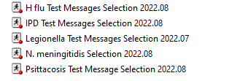

There are 4 SAS programs for MRCRS: Measles, Rubella, CRS, and CRS CORE. The SAS programs are saved here.

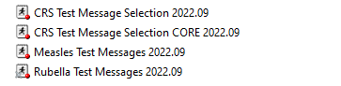

**Step1**: Change the state code, the number of cases users want to select for each reason and the total umber of cases users want to select.

/*Analysts need to change to appropriate state*/

%let statem=49;

/*Analysts can define the number of cases selected for each reason*/

%let nres=2;

/*Analysts can define total number of cases to select*/

%let allNum=50;

**Step2**: Change the output name if needed.

/*Analysts need to change to appropriate output path*/

%let outpath= \\cdc.gov\project\NIP_Project_Store1\Surveillance\NNDSS_Modernization_Initiative\MMG_Implementation\Jurisdiction Onboarding\&stabv.\MPV;

**Step3**: Change the year if needed.

/*Analyst will need to change years*/

**data** netss;

set nmi.stage2_netss;

keep rectype state year caseid site week event county birthd age agetype sex race hispanic casstat

outbrel outbr rectype state year caseid site week expanded_caseid datet eventd import;

where event=**10030** and year in (**2018**, **2019**,**2020**,**2021**,**2022**) and state=&statem.; /*change to appropriate year*/

**run**;

Output example: ***NCIRD_Requested_Legionella_Cases_Utah run on 27Jul2022.xlsx***

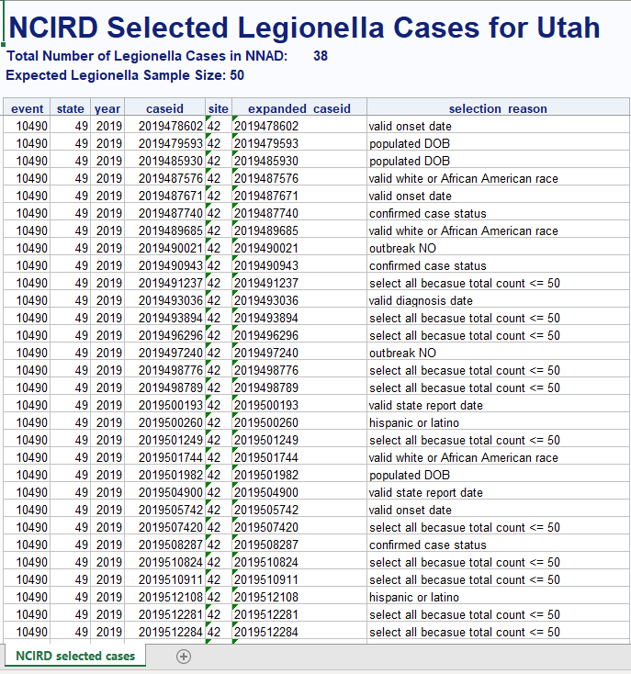

**Note**: You may notice some warnings regarding “CaseID not found” which is okay as it shows that some reasons are not found. It’s reasonable that there is no case in the database with some selection criteria.

**LPM Compare in Staging and Prod**

**Purpose**: After jurisdictions confirmed the transmission of the selected messages, we designed and implemented SAS programs for comparison. These programs compare Limited Production Cases in NNAD Staging with those in NNAD Production. We then present the comparison results to program users for review.

There is one combined MPV LPM compare SAS program, one Legionella LPM compare SAS program, one combined RIBD LPM compare SAS program, and one combined MRCRS LPM compare SAS program. They are saved here.

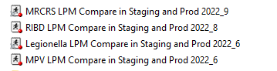

**Step1**: Update the state code.



**Step2**: Update the local record id list. You will need to update twice.

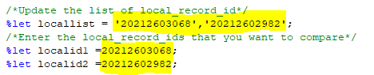

**Step3**: Update the output directory.



Output example: ***Utah LPM Comparison Results run on 15Jun2022.xlsx***

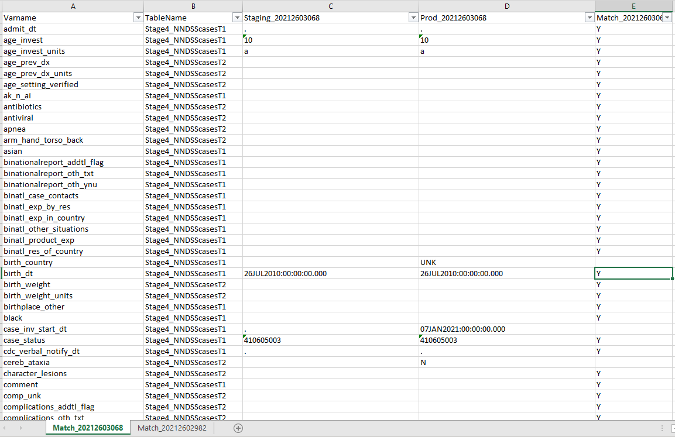

**Note**: Each case has one tab. Column E shows if each variable has the same value in Staging and Production or not. If the variable has the same value, a “Y” is automatically assigned.